**Final Project Part II**

**Hartschenko_alexander_ wpfregisterstudent**

Alexander Hartschenko

SNHU

IT-230: Software Development with C#.NET

Professor John Wetsch

December 15, 2024

**Final Project Part II**

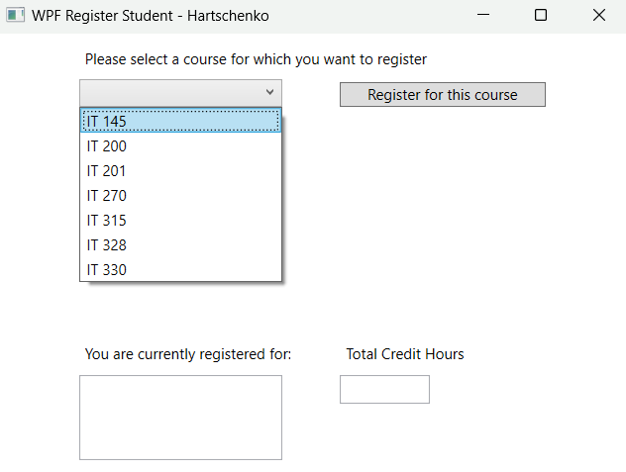

This screen is what initial displays after running the program. My name is displayed at the top. In the top left, there is a drop-down menu for the user to select their desired course. To the right of the menu, is a button for the user to click to confirm their course selection. This button is where the code is I added to its event handling. Below these is a box window to display the currently registered courses (left) and another box window to display the running total of credit hours the user has registered for (right).

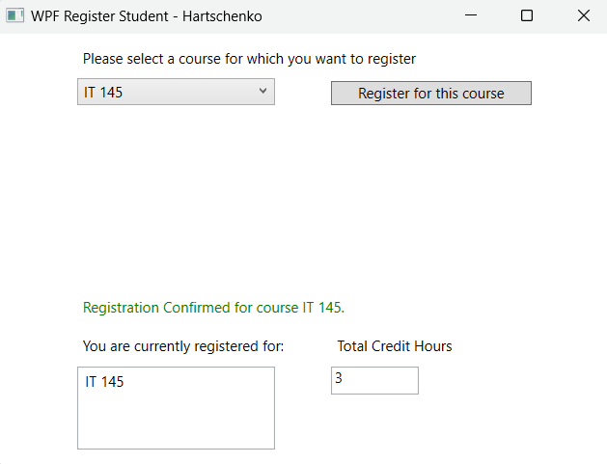

This screen shows that the user has registered for the course IT-145. A confirmation message appears just above the list of registered courses. I changed the confirmation message’s font color to be green for better user experience. The list of registered courses now contains course IT-145. The total credit hours have been updated to three since the user has only registered for two courses so far.

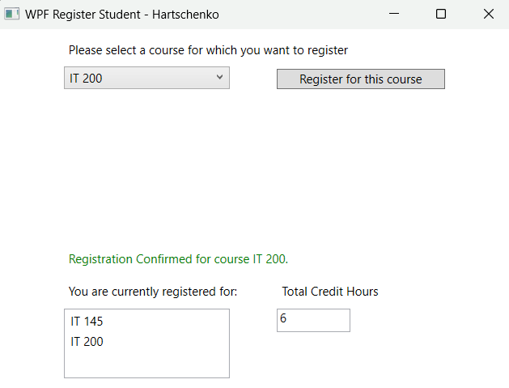

This screen shows that the user has registered for the course IT-200. A confirmation message appears just above the list of registered courses. This screen is almost identical to the previous one, just with a different course title. The course has been added to the list of registered courses and the credit hours is updated to six.

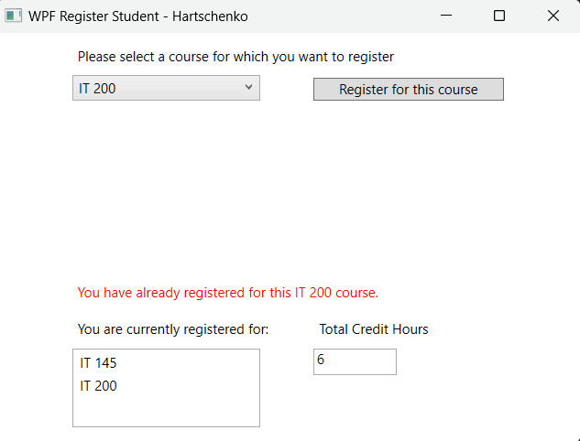

This screen shows that the user attempted to register for course IT-200 again. A message appears just above the list of registered courses telling the user that they have already registered for that course. The message is red for better user experience. The course is not added to the list again and the credit hours is unchanged.

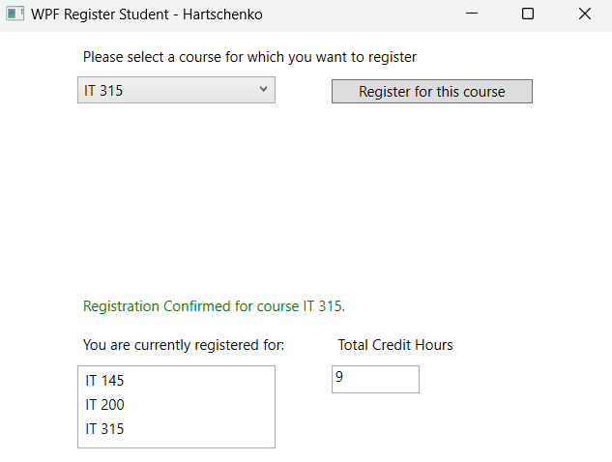

This screen shows that the user has registered for the course IT-315. A green confirmation message appears just above the list of registered courses. This screen is almost identical to the other screens of successful registration, just with a different course title. The course has been added to the list of registered courses and the credit hours is updated to nine. Nine is the maximum amount of credit hours the user can register for.

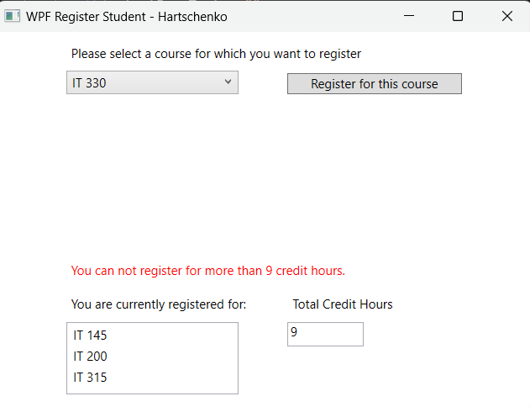

This screen shows that the user attempted to register for a fourth course. The user can only register for three courses with a total of nine credit hours. The program does not allow the user to register for this additional course. A red message appears just above the list of registered courses telling the user that they cannot register for more than nine credit hours. The selected course is not added to the list and the credit hours is not updated.

**Source Code**

/*

* Alexander Hartschenko

* IT 230 Final Project Part II

*

* For thos file, I mainly coded the button_Click event handling to tell the program what to do after the button has been clicked.

*/

using System;

using System.Collections.Generic;

using System.Linq;

using System.Text;

using System.Threading.Tasks;

using System.Windows;

using System.Windows.Controls;

using System.Windows.Data;

using System.Windows.Documents;

using System.Windows.Input;

using System.Windows.Media;

using System.Windows.Media.Imaging;

using System.Windows.Navigation;

using System.Windows.Shapes;

namespace WPFRegisterStudent

{

/// <summary>

/// Interaction logic for MainWindow.xaml

/// </summary>

public partial class MainWindow : Window

{

Course choice;

private int totalCredits = 0; // I added this variable to track credits

public MainWindow()

{

InitializeComponent();

}

private void Window_Loaded(object sender, RoutedEventArgs e)

{

Course course1 = new Course("IT 145");

Course course2 = new Course("IT 200");

Course course3 = new Course("IT 201");

Course course4 = new Course("IT 270");

Course course5 = new Course("IT 315");

Course course6 = new Course("IT 328");

Course course7 = new Course("IT 330");

this.comboBox.Items.Add(course1);

this.comboBox.Items.Add(course2);

this.comboBox.Items.Add(course3);

this.comboBox.Items.Add(course4);

this.comboBox.Items.Add(course5);

this.comboBox.Items.Add(course6);

this.comboBox.Items.Add(course7);

this.textBox.Text = "";

}

private void button_Click(object sender, RoutedEventArgs e)

{

choice = (Course)(this.comboBox.SelectedItem);

// TO DO - Create code to validate user selection (the choice object)

// and to display an error or a registration confirmation message accordingly

// Also update the total credit hours textbox if registration is confirmed for a selected course

// If the chosen course is already registered to

if (choice.IsRegisteredAlready())

{

this.label3.Foreground = Brushes.Red;

this.label3.Content = "You have already registered for this " + choice.ToString() + " course.";

}

// If the user has already registered for 9 credits (3 courses)

else if (totalCredits == 9)

{

this.label3.Foreground = Brushes.Red;

this.label3.Content = "You can not register for more than 9 credit hours.";

}

else

/*

* If the user can successfully register for a course:

* 1. Display confirmation

* 2. Add choice to list

* 3. Set the choice to registered

* 4. Add up the total credits

* 5. Update to box displaying the amount of credits

*/

{

this.label3.Content = "Registration Confirmed for course " + choice.ToString() + ".";

this.label3.Foreground = Brushes.Green;

this.listBox.Items.Add(choice);

choice.SetToRegistered();

totalCredits += 3;

this.textBox.Text = totalCredits.ToString();

}

}

}

}